Screenshots of Outputs
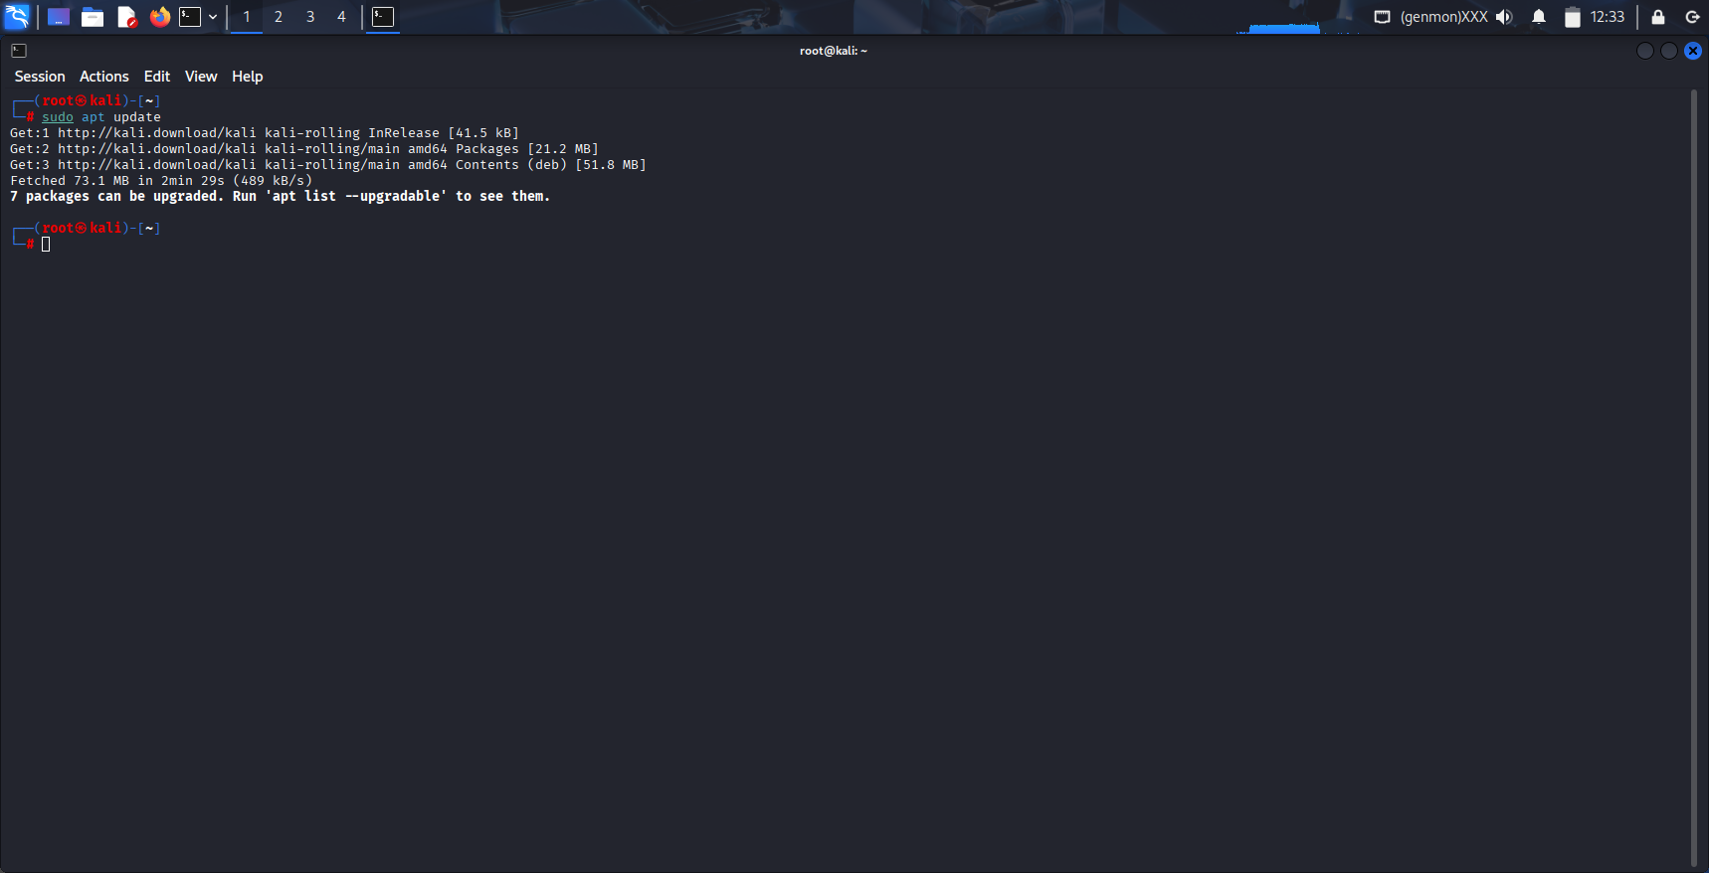
Fig. 1: Executing apt update on Kali Linux
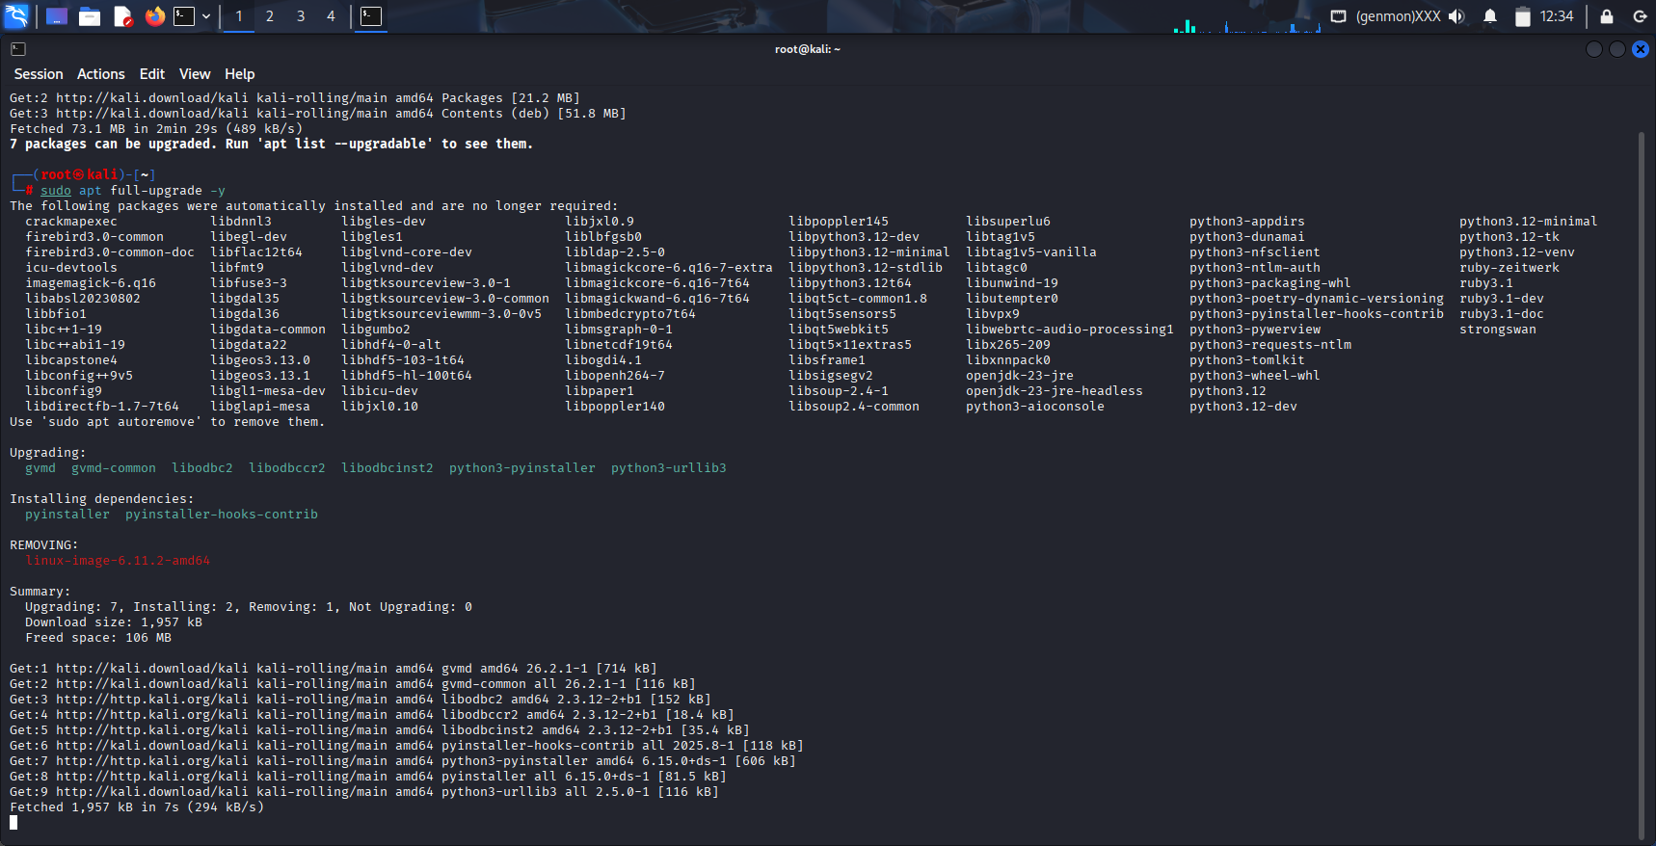
Fig. 2: Executing apt full-upgrade -y on Kali Linux

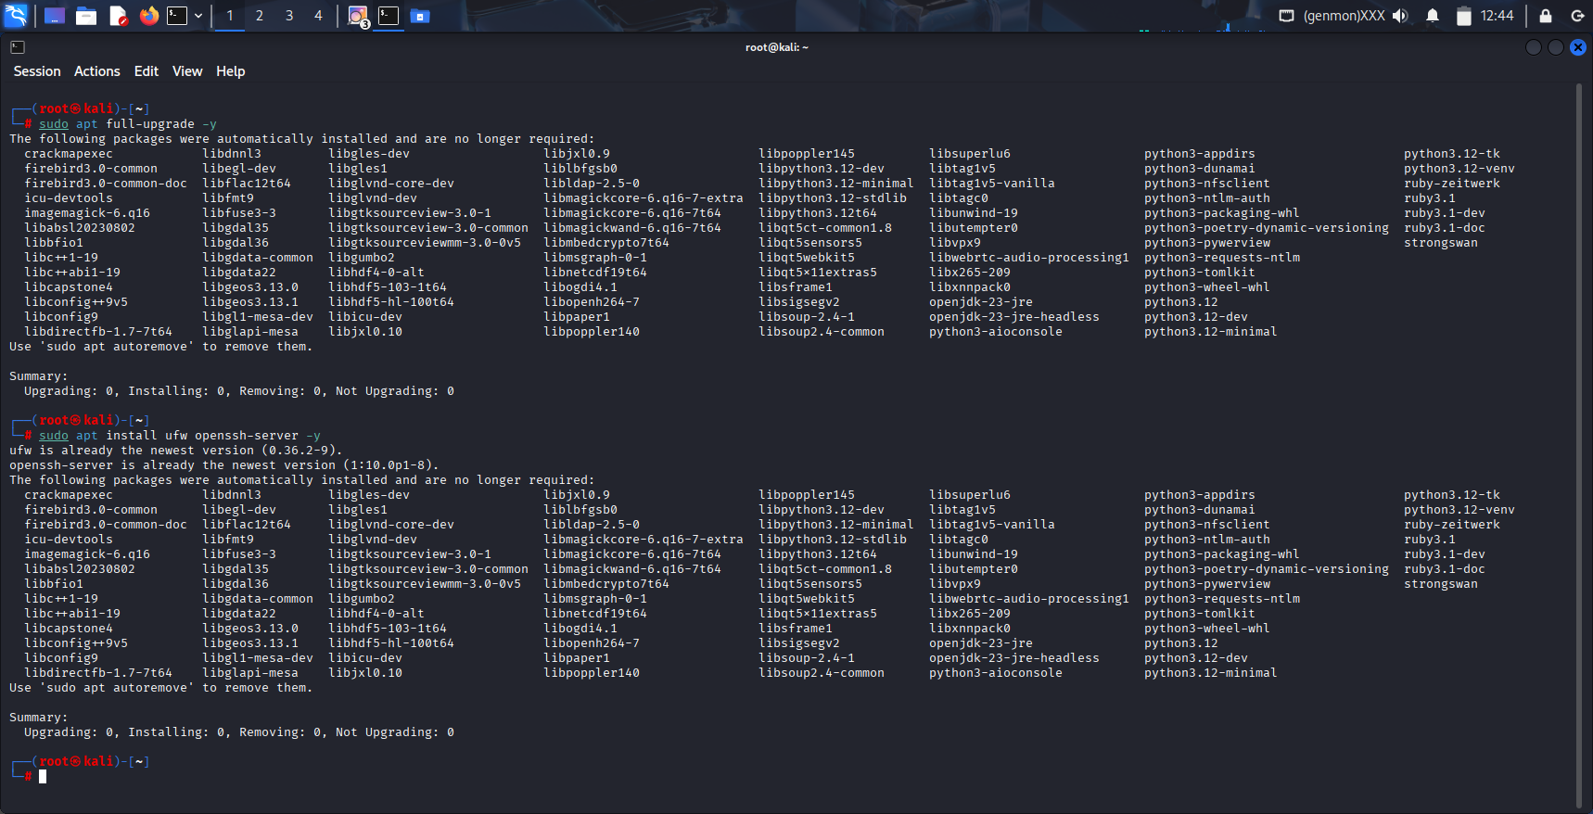
Fig. 3: Executing sudo apt install ufw openssh-server -y on Kali Linux

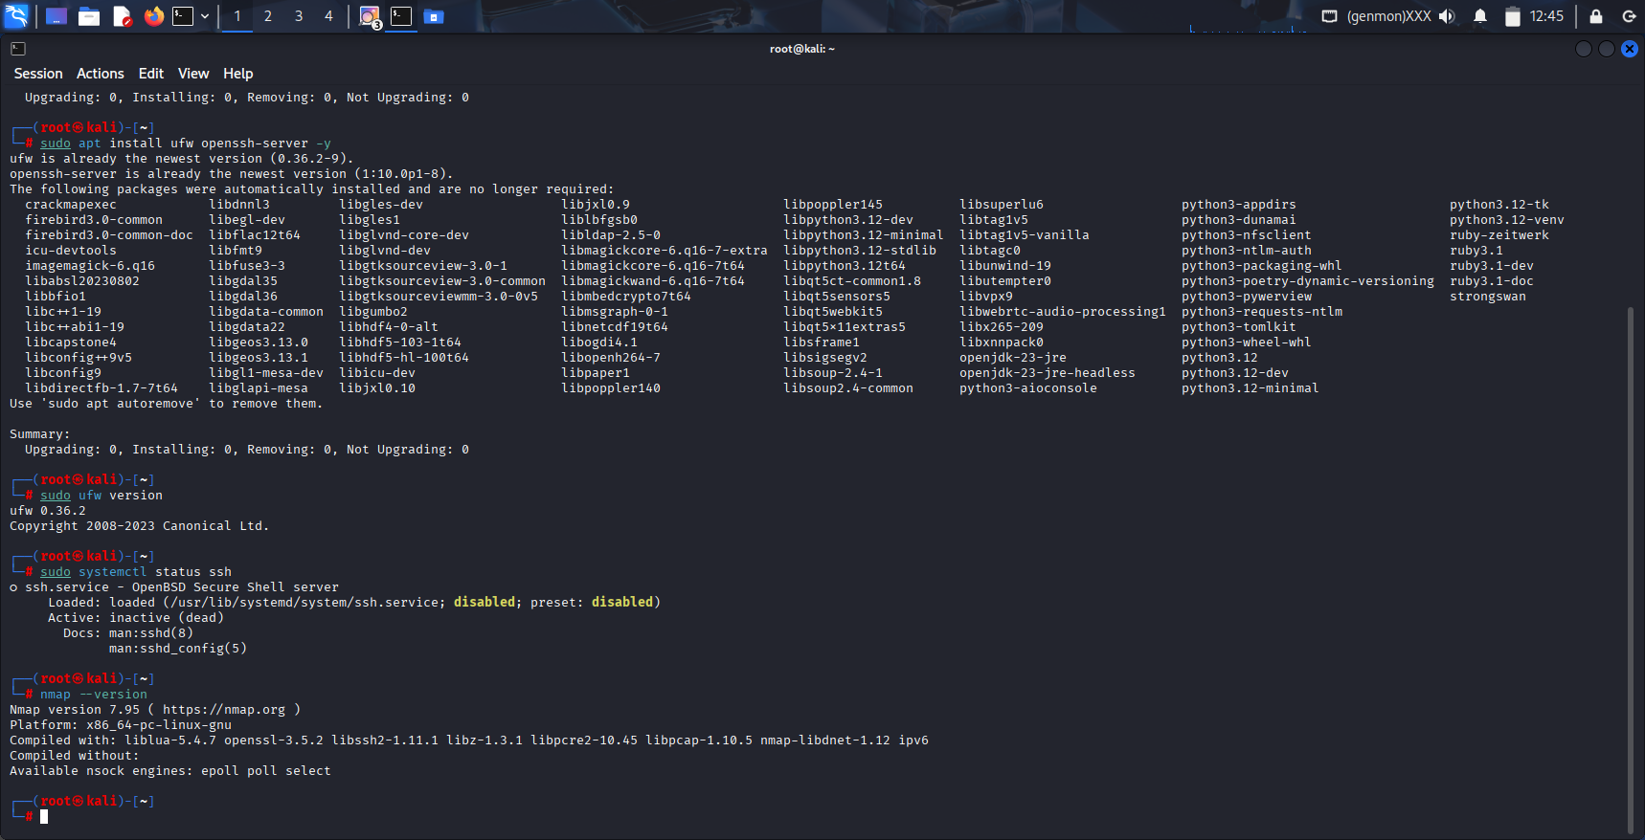
Fig. 4: Executing sudo ufw version, sudo systemctl status ssh, nmap –version on Kali Linux

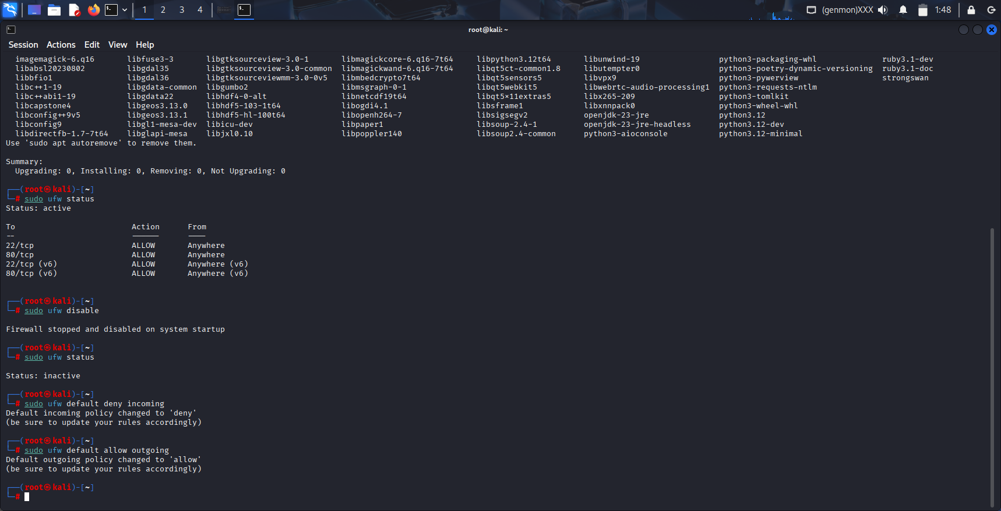
Fig. 5: Executing sudo ufw status on Kali Linux


Fig. 6: Executing sudo ufw default deny incoming on Kali Linux


Fig. 7: Executing sudo ufw default allow outgoing on Kali Linux

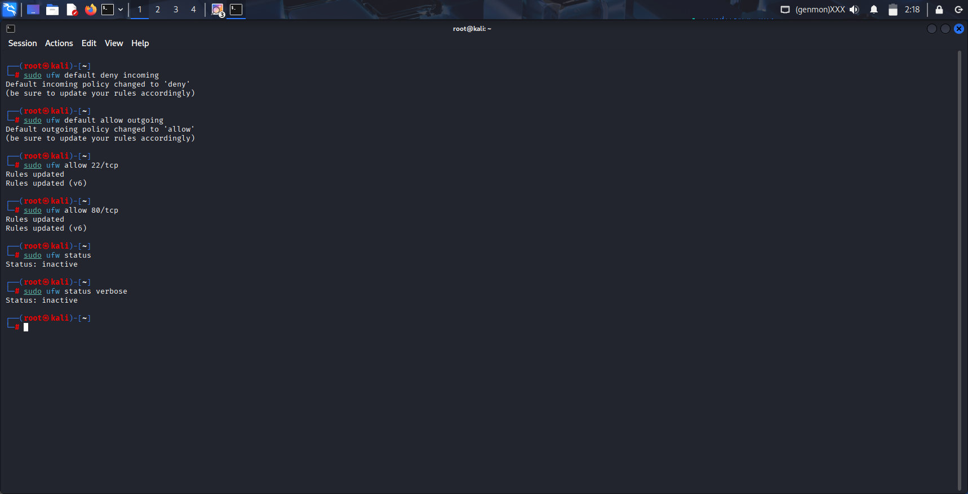
Fig. 8: Executing sudo ufw allow 22/tcp on Kali Linux


Fig. 9: Executing sudo ufw allow 80/tcp


Fig. 10: Executing sudo ufw status and the output is inactive


Fig. 11: Executing sudo ufw status verbose and the output is inactive

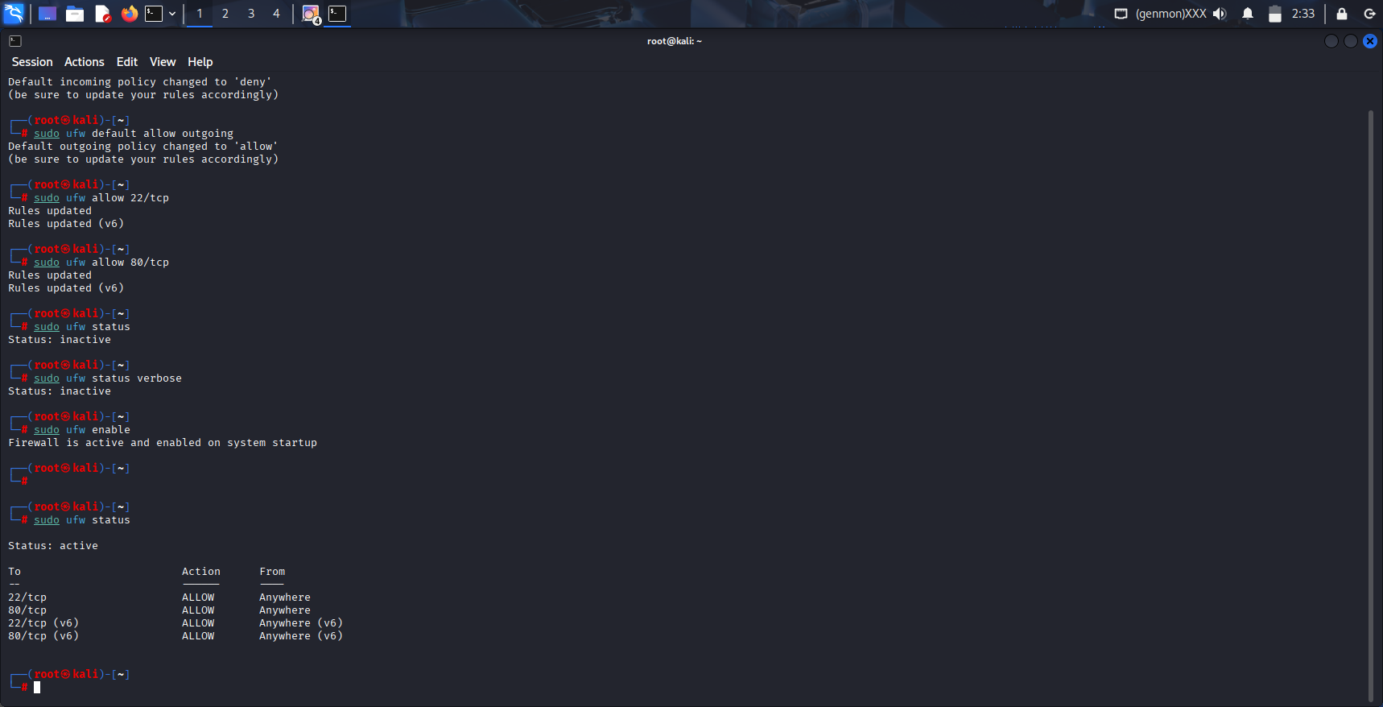
Fig. 12: Executing sudo ufw enable

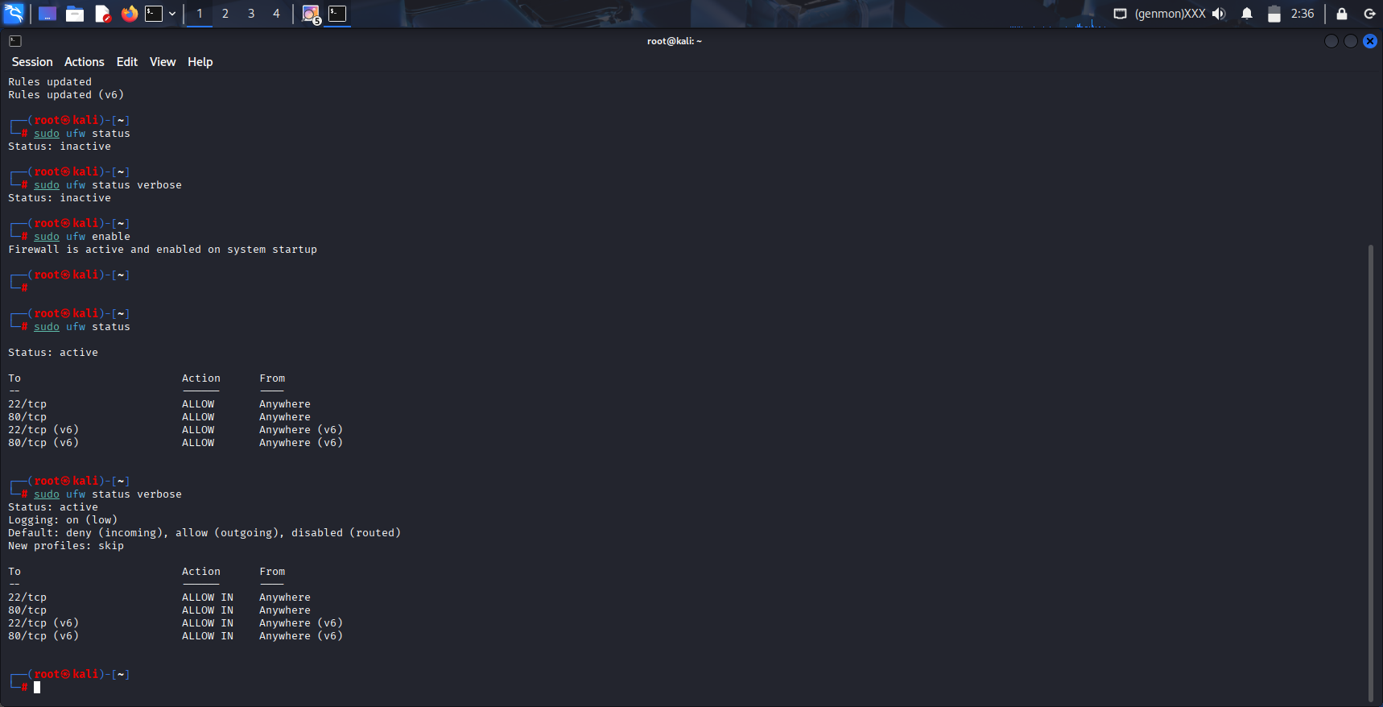
Fig. 13: Executing sudo ufw status verbose to verify firewall is active and rules are enforced

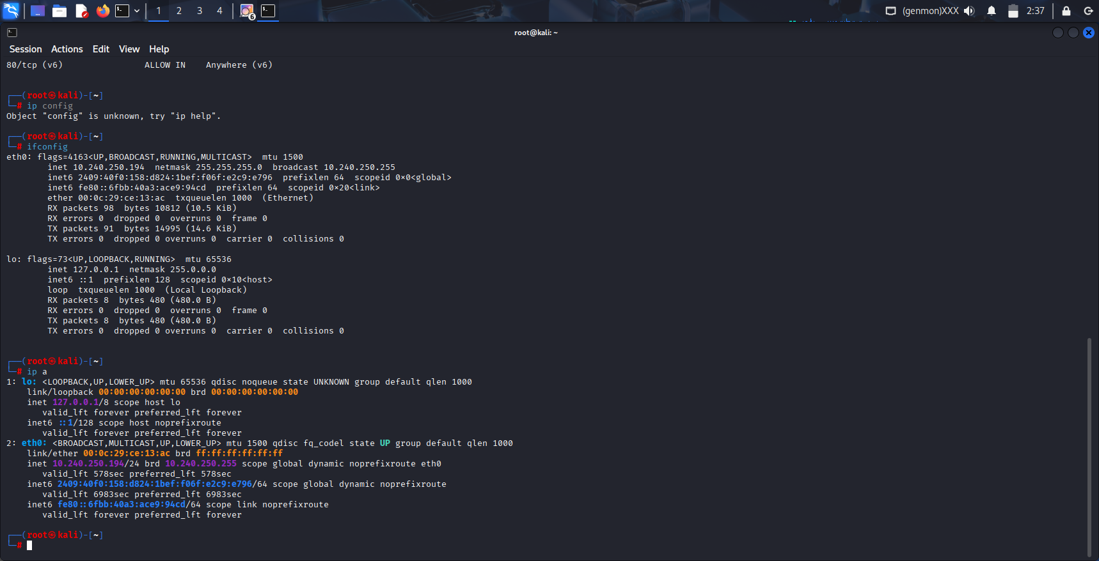
Fig. 14: Checking ip a

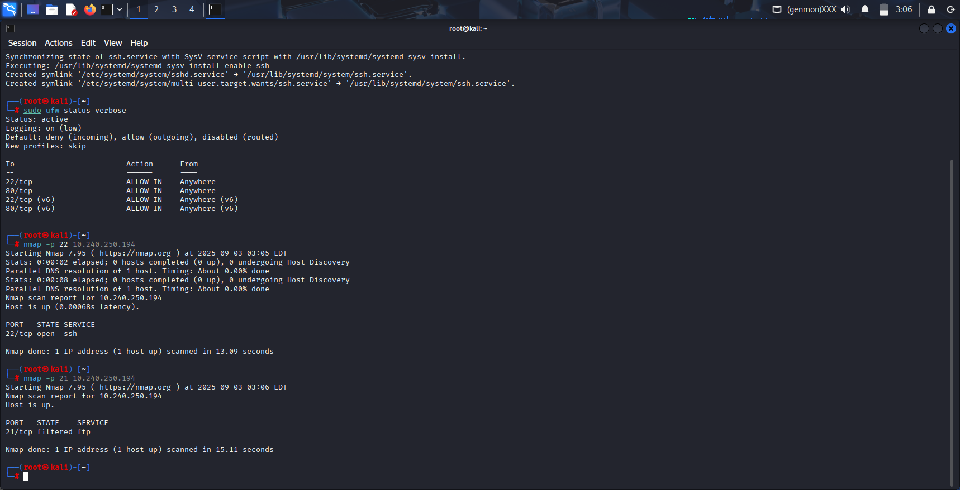
Fig. 15: Firewall is c allowing incoming TCP connections on port 80.


Fig. 16: Firewall is c allowing incoming TCP connections on port 21

